**Name: Rupam Tiwary**

**Reg. no: 12002950**

**Roll no.: RKE089A02**

**Subject: INT 219**

**CA-2**

**Q1.**

<!DOCTYPE html>

<html lang="en">

<head>

    <meta charset="UTF-8">

    <meta name="viewport" content="width=device-width, initial-scale=1.0">

    <title>Student Detail</title>

    <link rel="stylesheet" href="style.css">

</head>

<body background="OIP.jpeg">

    <*center*>

        <h1>Student Details</h1>

        <h2>Name-Rupam Tiwary</h2>

        <h2>Rgistration number-12002950</h2>

        <h2>Branch-Computer Science</h2>

        <h2>Front End Development</h2>

    </*center*>

</body>

</html>

body {

    background-image: url("OIP.jpeg");

    background-repeat:no-repeat;

    border: 10px;

    margin: 200px;

  }

  h1 {

    color:blue;

    margin: 20px;

    padding: 20px;

    font-style: italic;

    border: width 10px;

    border-style:solid;

    border-color: green;

  }

  h2{

    color:blue

    margin: 50px;

    padding: 50px;

  }

OUTPUT: -

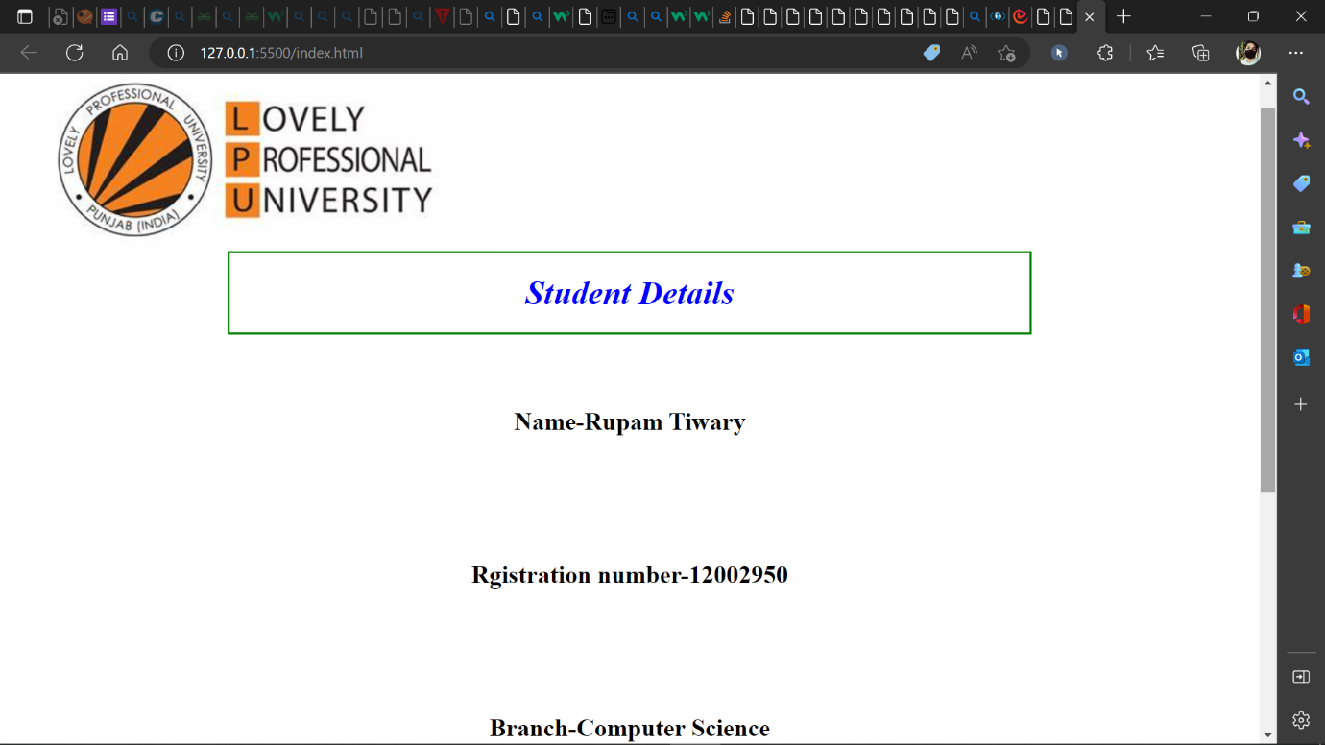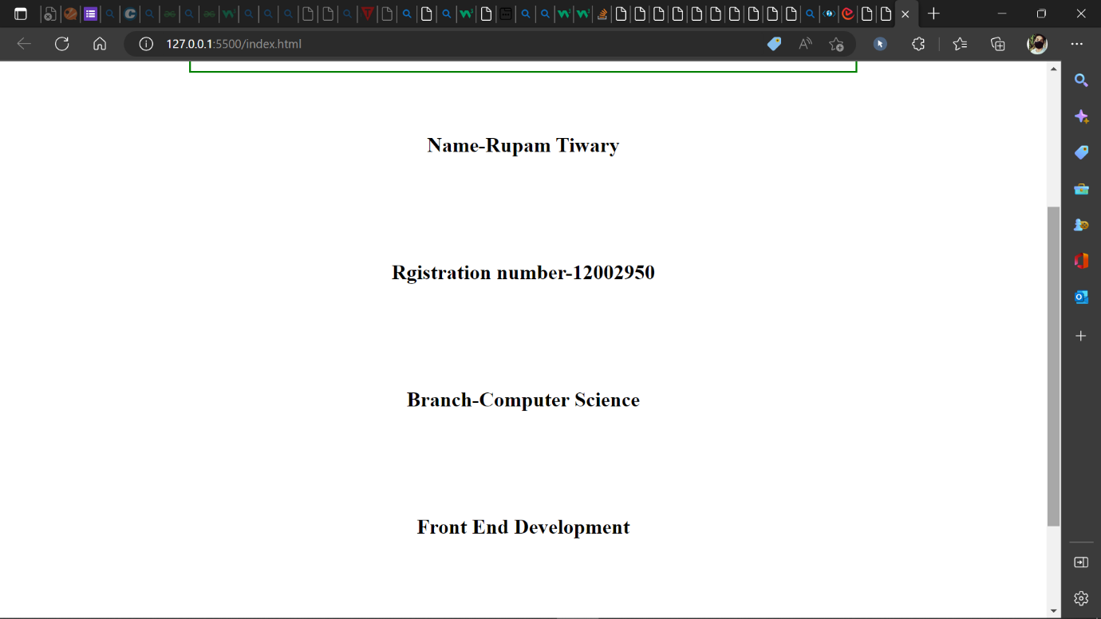

**Q2.**

OUTPUT: -

**Q3.**

<!DOCTYPE html>

<html lang="en">

<head>

    <meta charset="UTF-8">

    <meta http-equiv="X-UA-Compatible" content="IE=edge">

    <meta name="viewport" content="width=device-width, initial-scale=1.0">

    <title>Question 3</title>

</head>

<style>

    div{

        background-color: aqua;

        padding: 20px;

    }

    p{

        background-color: blue;

        padding: 20px;

    }

    button{

        background-color: brown;

        padding: 20px;

        border-radius: 2px;

        color: white;

    }

</style>

<script>

    function clickFun1(){

        window.alert("INT 219")

    }

    function clickFun2(){

        window.alert("12002950")

    }

    function clickFun3(){

        window.alert("Rupam Tiwary")

    }

</script>

<body>

    <*center*>

        <div onclick="clickFun1()">

            This is div

            <br><br><br>

            <p onclick="clickFun2()">Student Detail</p>

            <br><br><br>

            <button onclick="clickFun3()">Button</button>

        </div>

    </*center*>

</body>

</html>

OUTPUT: -

